First Login Page

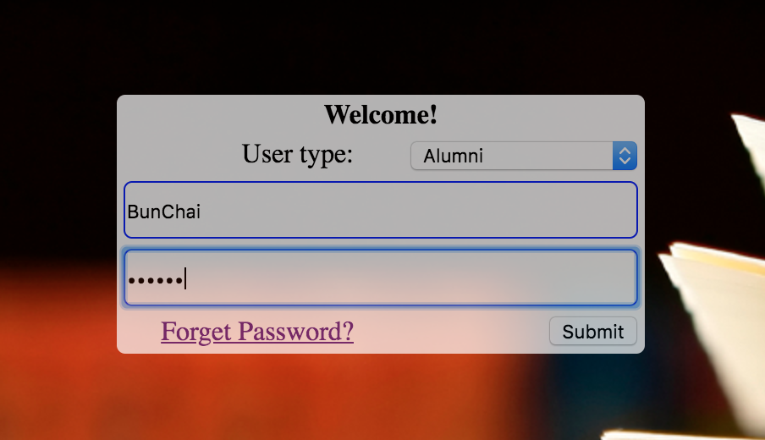

For first Login ,message is displayed, after, u will directed to this page.

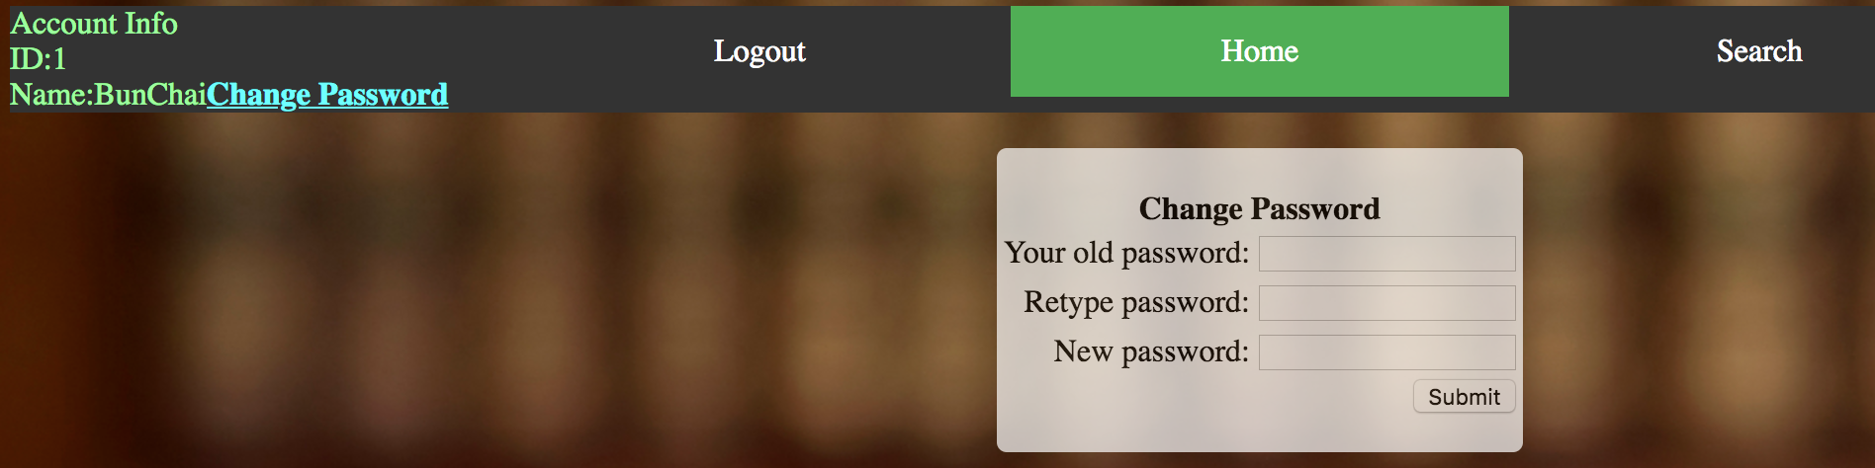

First Login user must change their password first. They can’t go to search unless they edit their password.

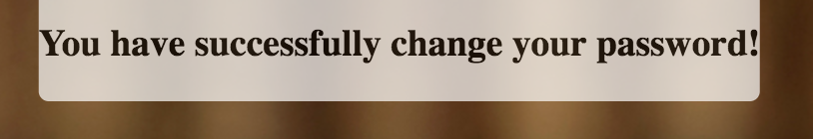

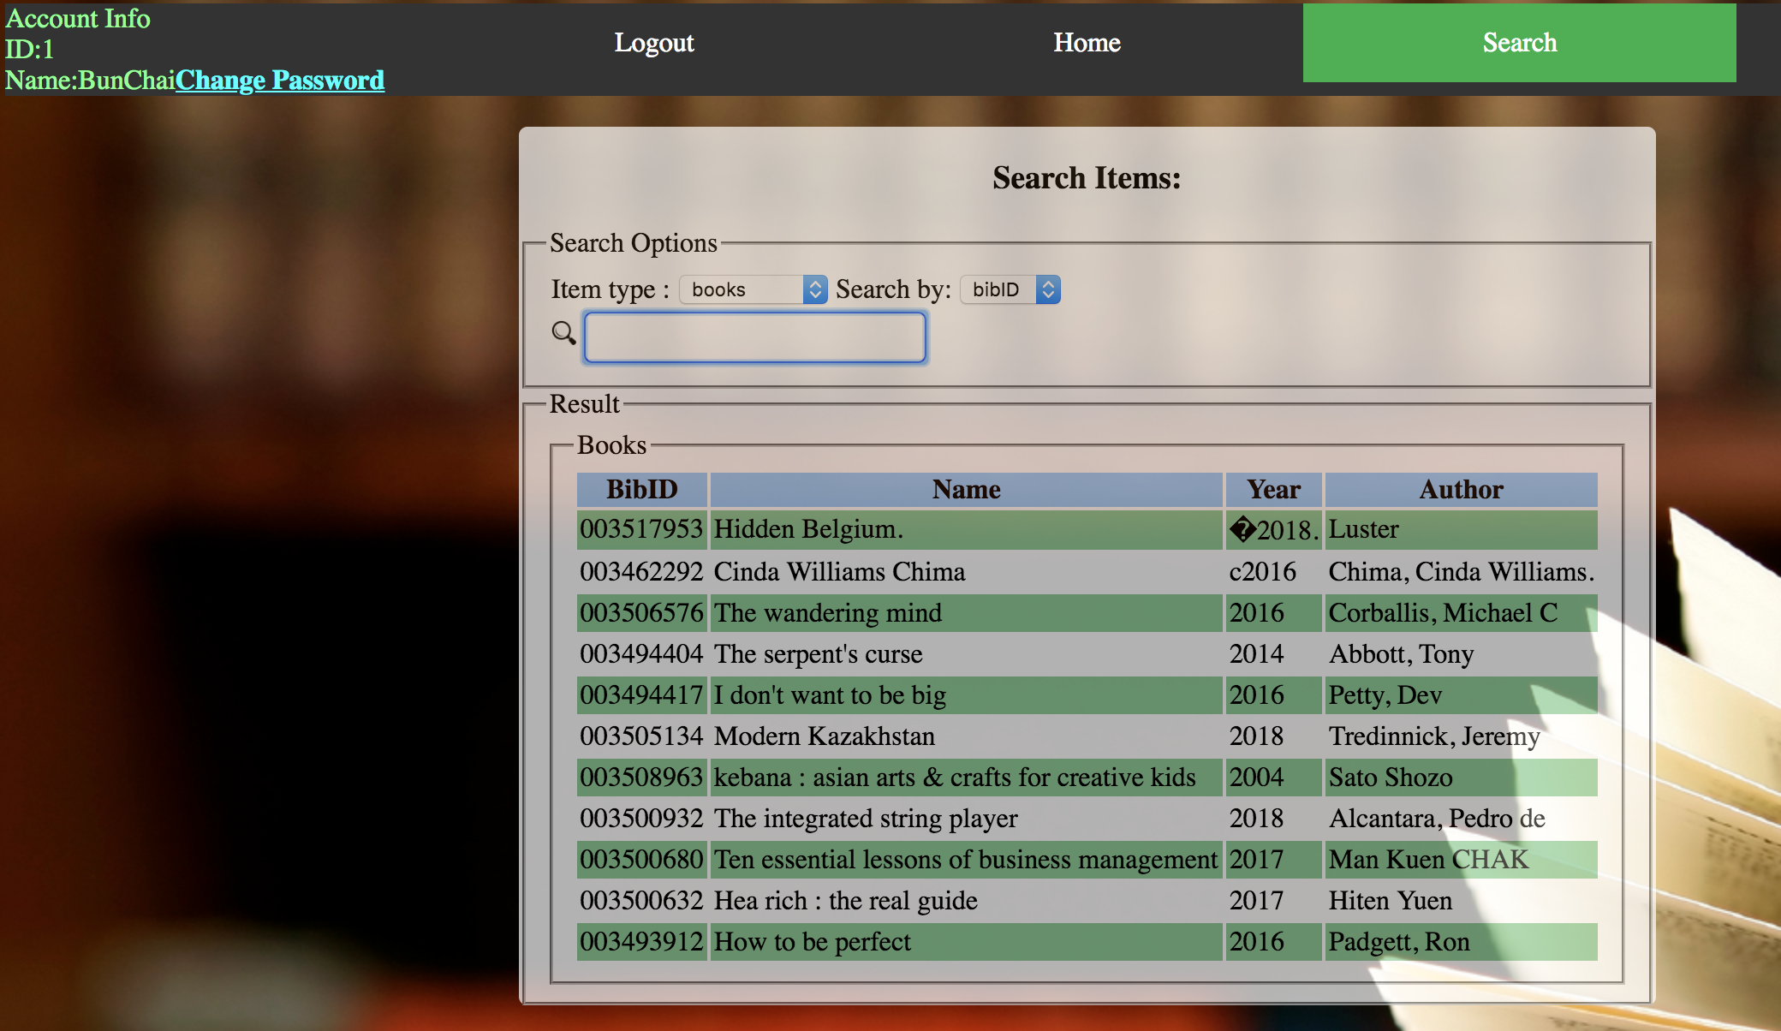

The image about shows the search function currently implemented. You can choose the search options above.

As an example.

Searching magazines by name with values “guide”

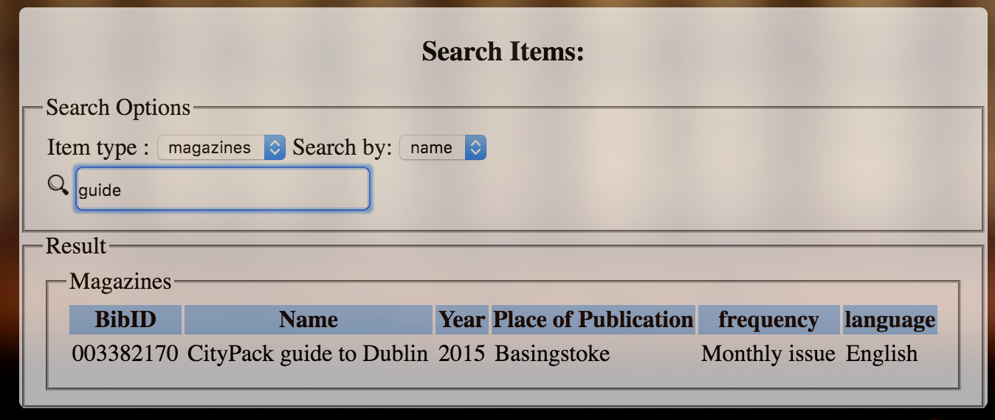

a pop up iframe will be show to display the photo of the book.

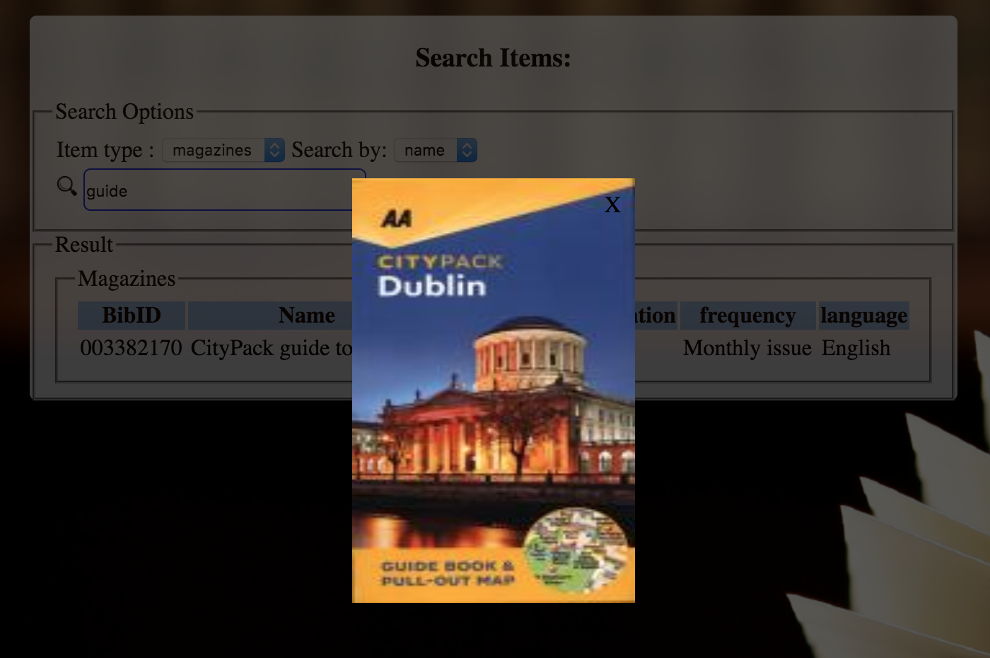

Forget Password!

